***Project Report***

***Executive Summary:***

Due to its high combustion efficiency and capacity to produce more power units, coal has dominated US power generation for several decades. But the energy revolution has made natural gas an attractive substitute that offers better performance and lower costs. Future coal use is anticipated to be replaced by natural gas due to the reduced cost and availability of these fuels, as well as their favourable environmental effects.

***Recommendations:***

It is essential to cut back on environmental pollution if we are to address the worldwide problem of climate change. The production of electricity contributes significantly to pollution; therefore, it is advised to switch to cleaner fuel sources, such as solar energy, biogas, and natural gas, which produce fewer pollutants.

***Problem Statements***

* What are the primary fuel types utilized for power generation in the United States?
* What pollutants are released into the atmosphere during the power generation process?
* Do these emissions comply with the permissible limits?
* What is the average cost associated with power generation in the US?
* How much fuel is consumed to generate power in the US?

***Selection of the optimal segmentation and its significance in understanding power generation in the US:***

Ans. The most effective segmentation for gaining a comprehensive understanding of power generation in the US would be based on the power sources that yield the highest number of power units, measured in metric million thermal units. This segmentation should also consider factors such as reasonable costs and the quantity of fuel units consumed. By analyzing these metrics, we can identify the power sources that generate the greatest amount of power while maintaining a balance between cost-effectiveness and fuel consumption.

Cluster 1: This cluster predominantly utilizes petroleum and natural gas as fuel sources for power generation. The median cost for generating power units with a heat content of 5.8 million metric British thermal units (MMBtu) is $11.6. This cluster generates a total of 828 units, and no impurities of Sulphur, mercury, or ash content are detected.

Cluster 2: Natural gas and other gases are the primary fuel sources in this cluster. The median cost for generating power units with a heat content of 1.0270 MMBtu is $3.276. This cluster generates approximately 22,154.5 units of power, and there are no impurities of Sulphur, mercury, or ash content.

Cluster 3: This cluster also relies on natural gas as its fuel source. The median cost for 1.0300 natural gas units is $3.276. It generates a significant amount of power with 2,069,810.0 units, which is the second highest among all clusters. No impurities are observed in this cluster.

Cluster 4: The fuel source in this cluster is coal. The price for generating power units with a heat content of 18.0220 MMBtu is $2.643. This cluster generates a total of 25,185.0 units of power. However, it exhibits impurities of ash exceeding the permissible levels at 0.65 parts per million (ppm) and Sulphur at 0.0044 ppm.

Cluster 5: Natural gas is once again the fuel source in this cluster. The median cost for generating power units, which includes extreme outliers, is $6010.289 for a heat content of 1.0370. This cluster generates a minimal amount of power, with only 27.0 units, and no impurities are present.

Cluster 6: Coal serves as the fuel source in this cluster. The price for generating power units with a heat content of 22.2140 MMBtu is $3.276. This cluster generates a total of 9,532.0 units of power. However, it surpasses the permissible levels of ash impurities at 2.02 ppm and Sulphur at 0.0245 ppm. Additionally, there is a presence of mercury impurities at 0.00038.

Cluster 7: Among all the clusters, this cluster generates the highest number of gas units for power generation, amounting to 5,364,812.0 units. The fuel sources used are natural gas and other gases. The price for generating power units with a heat content of 1.0255 MMBtu is $3.276. No impurities are detected in this cluster.

Cluster 8: This cluster utilizes coal and petroleum coke as fuel sources. The price for generating power units with a heat content of 23.3515 MMBtu is $2.916. It generates a total of 18,815.0 units of power. However, the cluster exhibits impurities of ash surpassing the permissible levels at 0.91 ppm, and Sulphur levels exceeding the permissible limit at 0.0283 ppm.

***Facts:***

The future is all about uncertainties and the trend which is observed at present might not be the same in the future.

In the United States coal has been a major source for generating power for decades, but due to some factors, we are seeing a churn in the fuel source being used for power generation in the US.

* Increase in Dollar Rate,
* Greenhouse Gases Emission Regulation,
* Cheaper Natural Gas

As per ***CNBC***, “In the US fuel source used to generate power in 2010 was Coal - 44% and Natural Gas - 21% and presently it is Coal at 30% and Natural Gas at 31%. [6]

This decline in the fuel source is expected to continue and there will be a day when the sole source used to generate power would be Natural Gas alone, “***CNBC Expert Discussion Panel”***.

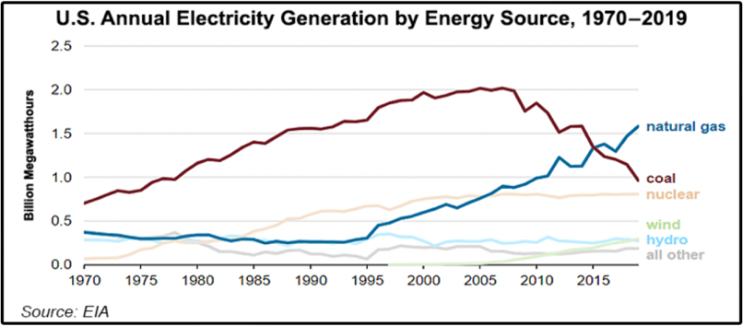

***Discussion – (Future Power Generation in the United States – CNBC) [6]***

* There is a possibility that the usage of high amounts of fuel units of natural gas will lead to excess power generation when compared to that of coal as a fuel source.
* The availability of Natural Gas at a cheaper price can be one main driving factor for the use of natural gases in more quantity to generate power in the US in the future.

***Findings***

* The analysis of power generation clusters in the US reveals valuable insights into different fuel sources, costs, generated units, and impurities. Cluster 1 primarily relies on petroleum and natural gas, generating 828 units without any impurities. Cluster 2 and Cluster 3 both utilize natural gas, with Cluster 2 generating 22,154.5 units and Cluster 3 generating 2,069,810.0 units, both without impurities.
* Cluster 4 relies on coal, generating 25,185.0 units, but with impurities exceeding permissible levels. Cluster 5 also uses natural gas, generating only 27.0 units without any impurities. Cluster 6 utilizes coal, generating 9,532.0 units with high levels of ash and Sulphur impurities, as well as traces of mercury.
* Cluster 7 stands out with the highest number of gas units generated (5,364,812.0 units) and no impurities. Cluster 8 combines coal and petroleum coke, generating 18,815.0 units but with elevated levels of ash and Sulphur impurities.
* These findings highlight the varying characteristics of different fuel sources for power generation in terms of cost, generated units, and impurities. Natural gas clusters demonstrate favourable outcomes in terms of cost-efficiency, high generation, and absence of impurities. On the other hand, coal clusters show lower cost but come with environmental concerns due to impurities. The analysis emphasizes the potential for natural gas to play a significant role in future power generation, given its lower cost, environmental benefits, and high unit generation.

***Conclusion –***

In summary, power generation in the US is characterized by a broad diversification of fuel sources. The use of different fuel types results in varying quantities of power units being generated, accompanied by additional costs and environmental pollutants. The key lies in selecting a specific fuel type based on the specific requirements and objectives. Coal, despite its environmental impact, has the advantage of generating a higher number of power units. However, this comes at the expense of polluting the environment with impurities.

On the other hand, natural gas generates fewer power units but releases fewer pollutants into the atmosphere. If the primary objective is to maximize power generation by increasing the number of power units, coal can be utilized as the primary fuel source. However, if the aim is to comply with regulations on greenhouse gas emissions and control pollutant levels, natural gas would be a more suitable choice as the primary fuel source.

***Appendix:***

1. [Form EIA-923 detailed data with previous form data (EIA-906/920)](https://www.eia.gov/electricity/data/eia923/)
2. <https://www.investopedia.com/terms/s/sourcrude.asp>
3. <https://www.eia.gov/todayinenergy/detail.php?id=29812>
4. <https://www.cnbc.com/2015/07/14/natural-gas-tops-coal-as-top-source-of-electric-power-generation-in-us.html>